**“Support Sail”**

“One stop for all support needs” - “Online Platform for All you can Donate”

***Dissertation Submitted in Partial fulfilment of the***

***Requirement for the Award of the Degree of***

Master of Technology in Information Technology

***Semester VII***

*Session July-Dec, 2023*

**Under the guidance of - Submitted By-**

**Dr. Rahul Singhai sir Aaftab Patel (TT-2K20-02)**

**Gulam Waris Sheikh(IT-2K20-22)**

**International Institute of Professional Studies**

**Devi Ahilya Vishwa Vidyalaya, Indore**

**2023**

**DECLARATION**

We, Aaftab Patel and Gulam Waris Sheikh, solemnly declare that the project entitled “SupportSail” which is submitted by us for the partial fulfilment of requirement for the award **of Master of Technology in Information technology (5 years) semester VII** to International Institute of Professional Studies, Devi Ahilya Vishwavidyalaya, Indore, is authentic record of our own work carried out under the supervision of Dr. Rahul Singhai, Senior Assistant professor, International Institute of Professional Studies, DAVV, Indore.

The matter embodied in this dissertation work is authenticated and is genuinely done by us and has not been submitted to this university or any other university or Institute. Thus, we solely own the responsibility for the originality of the entire content.

We also declared that the content of project report does not violate the copyright, Trademarks, infringes on the patent, statutory right or propriety right of others.

All resources utilized for this project have been duly cited and referenced. Any assistance received during the preparation of this report has been acknowledged within.

We further declare that this project report has not been previously been submitted by us or anyone for any other purpose.

Aaftab Patel Gulam Waris Sheikh

Date: Dec’ 23

**CERTIFICATE FROM GUIDE**

It is to certify that I, Dr Rahul Singhai, have supervised the project work titled "Support Sail” undertaken by Aaftab Patel and Gulam Waris Sheikh, towards the completion of Masters of Technology (5 yrs.) at International Institute of Professional Studies (IIPS).

I hereby confirm that I have provided guidance, support, and necessary assistance throughout the duration of this project. I have reviewed the progress and content of the report and believe that it is a result of the candidate's own work, except where explicitly acknowledged.

To the best of my knowledge and belief, this project report fulfils the requirements and standards expected for the successful completion of the Masters of Technology (5 yrs.).

I recommend the submission of this report for evaluation and assessment.

Date: Dec’ 23

Supervisor's Name: Dr Rahul Singhai

Designation: Senior Lecturer

Institution: International Institute of Professional Studies (IIPS)

Signature:

**CERTIFICATE**

This is to certify that the project work titled "Support Sail” submitted by Aaftab Patel and Gulam Waris Sheikh in partial fulfilment of the requirements for the completion of Masters of Technology (5 yrs.) at International Institute of Professional Studies (IIPS) has been successfully completed under my supervision.

The project work has been examined and evaluated by the undersigned and is deemed to be satisfactory in terms of its scope, quality, and adherence to the guidelines set forth.

I commend the effort, dedication, and scholarly rigor demonstrated by Aaftab Patel and Gulam Waris Sheikh in the completion of this project.

Internal Examiner External Examiner

Signature: ________________ Signature: ______________

Name: ________________ Name: _______________

Date: _______________­ Date: _______________

**ACKNOWLEDGEMENT**

We would like to express my sincere gratitude and appreciation to everyone who contributed to the completion of this project titled "Support Sail”.

First and foremost, we extend our heartfelt thanks to my supervisor, Dr Rahul Singhai, for their invaluable guidance, continuous support, and insightful feedback throughout the duration of this project. Their expertise and encouragement have been instrumental in shaping the direction and content of this report.

we are also grateful to all College staff for their assistance and provision of necessary resources that facilitated the completion of this project.

Thank you to everyone who contributed directly or indirectly to this project. Your support has been immensely appreciated.

Furthermore, we acknowledge the understanding and the support received from my family and friends whose encouragement and patience were invaluable during the challenging phases of this endeavour.

Aaftab Patel (IT-2K20-02)

Gulam Waris Sheikh (IT-2K20-22)

**ABSTRACT**

The Project Entitled “SupportSail”, is a powerful platform that serves as a nexus for individuals driven to make a difference and organizations dedicated to positive change. This deals with everything related to “Donate, Help & Support”. Our mission is to facilitate seamless connections between passionate individuals and impactful causes.

Whether you're looking to donate, volunteer, or connect with organizations, our platform provides a user-friendly space for collaboration. For organizations, we offer a hub to connect with enthusiastic volunteers, collaborate with other organizations, and share resources.

We aim at building a community where kindness and collaboration drive meaningful change. Where people can come and do all related to donation. Want to be a Donator come to Support Sail, want to be a Volunteer come to Support Sail, Want to get a donation come to Support Sail, Want to join a community of people who strive to a common goal come join us at Support Sail.

We emphasis on user-friendliness as it is crucial to ensures accessibility, encouraging more people to participate in acts of kindness and social change. Additionally, providing a space for organizations to collaborate, share resources, and connect with passionate volunteers strengthens the ecosystem for positive impact.

**TABLE OF CONTENTS**

|  |  |
| --- | --- |
| 1. INTRODUCTION | Pg. No. |
|  |  |
| * 1. Problem Definition | 9 |
| * 1. Aim | 10 |
| * 1. Objectives | 11 |
| * 1. Project Goals | 11 |
| * 1. Benefits | 12 |
|  |  |
| 1. Current And Proposed System |  |
|  |  |
| * 1. Current System | 14 |
| * 1. Proposed System | 15 |
|  |  |
| 1. Feasibility Study |  |
|  |  |
| * 1. Feasibility Analysis | 18 |
| * 1. Economic Feasibility | 18 |
| * 1. Technical Feasibility | 19 |
| * 1. Behavioural Feasibility | 22 |
|  |  |
| 1. Analysis |  |
|  |  |
| * 1. Questionnaire | 23 |
| * 1. Analysis Of Existing Portals | 24 |
|  |  |
| 1. Project Planning |  |
|  |  |
| * 1. Project Scope | 29 |
| * 1. Development Plan | 31 |
| * 1. Team Structure | 32 |
| * 1. Project Deliverables | 32 |
|  |  |
| 1. Design |  |
|  |  |
| * 1. Logical Design | 33 |
| * + 1. Entity Definition | 33 |
| * + 1. Attribute Definition | 33 |
| * 1. Physical Design | 34 |
| * + 1. User Interface | 34 |
| * + 1. Backend | 41 |
|  |  |
| 1. Implementation | 44 |
|  |  |
| 1. Testing |  |
|  |  |
| * 1. Black Box Testing | 45 |
| * 1. White Box Testing | 46 |
| * 1. Unit Testing | 47 |
| * 1. Integration Testing | 47 |
| * 1. System Testing | 47 |
|  |  |
| 1. FUTURE PROSPECTIVE | 48 |
|  |  |
| 1. LIMITATIONS AND CONCLUSIONS | 49 |
|  |  |
| 1. BIBLOGRAPHY & REFERENCES | 51 |

1. **INTRODUCTION**

1.1 Problem Definition and Our Approach

The following problem are aced by the users in existing donation platforms-

1. Lack of Transparency

Existing Issue: Users often express concern about where their donations go and how they are utilized by organizations.

SupportSail Approach: Implement transparent reporting and updates on how donations are utilized. Provide detailed information on the impact of contributions.

2. Complicated User Experience

Existing Issue: Donation platforms can sometimes be confusing or difficult to navigate, deterring users from contributing.

SupportSail Approach: Focus on a user-friendly interface with intuitive navigation. Simplify the donation process and offer clear guidance throughout the platform.

3. Limited Engagement Opportunities

Existing Issue: Users might feel disconnected from the impact of their donations or lack opportunities to get involved beyond monetary contributions.

SupportSail Approach: Offer various engagement options like volunteering, sharing resources, or collaborating directly with organizations. Provide real-time updates on the impact achieved.

4. Trust and Credibility Concerns

Existing Issue: Some users hesitate to donate due to concerns about the credibility of organizations or platforms.

SupportSail Approach: Implement rigorous verification processes for organizations and ensure transparency in their activities. Highlight verified and trusted organizations.

5. Inadequate Communication

Existing Issue: Users might not receive enough communication regarding their contributions or the overall progress of causes.

SupportSail Approach: Set up clear communication channels, sending regular updates on the impact achieved, stories of change, and the collective progress of initiatives.

6. Limited Community Engagement

Existing Issue: Lack of a vibrant community or interaction between donors, volunteers, and organizations can reduce overall engagement.

SupportSail Approach: Foster a community-driven platform with forums, discussions, and opportunities for users to interact, collaborate, and share their experiences.

7.Existance of only one or two features at one platform

Existing Issue: current websites are monotonic providing only single feature like donate, communicate, organise events, join as volunteer, donate blood etc.

SupportSail Approach: we have a community platform which has all these and more all at one place so you don’t have to search anywhere else.

**1. 2 Aim**

The core aim of SupportSail is to serve as a unifying platform, a nexus where the aspirations of individuals intersect with the missions of organizations dedicated to positive change. It endeavours to create a seamless space, a virtual harbour, where passionate individuals seeking to make a difference find an avenue to contribute, be it through donations, volunteering, or collaboration. SupportSail is driven by the vision of fostering impactful connections, empowering users to engage effortlessly with causes they care about. Beyond facilitating transactions, it strives to cultivate a vibrant community, where empathy, collaboration, and collective efforts fuel meaningful transformations. Transparency, trust, and user-friendly engagement lie at the heart of its mission, aiming not just for isolated acts of generosity, but for a ripple effect of lasting change that reverberates through society.

**1. 3 Objectives**

The objectives of SupportSail are intricately woven into its overarching aim of fostering a collaborative, transparent, and impactful platform dedicated to driving positive societal change. At its core, SupportSail aims to facilitate seamless connections between individuals driven to make a difference and organizations committed to meaningful causes. To achieve this, the platform endeavours to provide a user-friendly interface that simplifies engagement, promote transparency by ensuring clear insights into donation utilization and organization verification, and foster a vibrant community where empathy and collaboration thrive. With a focus on enhancing user accessibility, building trust through transparency, and encouraging active participation, SupportSail's objectives centre around empowering users to contribute, collaborate, and collectively drive tangible social impact.

**4 Project Goals**

* Facilitate Collaborative Connections

Goal: Enable seamless connections between passionate individuals and impactful organizations to foster collaboration and drive positive change.

* Ensure User-Centric Experience

Goal: Prioritize user experience by offering an intuitive, user-friendly platform that encourages diverse forms of engagement and participation.

* Promote Transparency and Trust

Goal: Establish and maintain transparency in donation utilization, organization verification, and reporting to build trust among users.

* Cultivate a Supportive Community

Goal: Foster a vibrant and interactive community space where users can connect, share experiences, and collaborate towards common causes.

* Drive Tangible Social Impact

Goal: Empower users and organizations to contribute meaningfully, leading to measurable and sustainable social impact across various initiatives.

* Innovate for Continuous Improvement

Goal: Embrace innovation and continuous improvement by evolving the platform to meet evolving user needs and societal challenges.

* Expand Reach and Accessibility

Goal: Expand the platform's reach to a wider audience, ensuring accessibility for diverse demographics and geographic regions.

* Champion Empathy and Collaboration

Goal: Champion values of empathy and collaboration, encouraging a culture of kindness and collective action among users and organizations.

* Establish SupportSail as a Leading Platform

Goal: Position SupportSail as a leading, trusted platform for connecting individuals and organizations dedicated to fostering positive change globally.

**1. 4 Benefits**

For Users

* Effortless Contribution: Users can easily contribute to causes they care about, whether through donations, volunteering, or sharing resources, fostering a sense of fulfilment and empowerment.
* Transparent Impact: Enjoy clear insights into how their contributions are utilized, ensuring transparency and trust in the process.
* Community Engagement: Access a vibrant community space where users can connect, share experiences, and collaborate, fostering a sense of belonging and shared purpose.
* Diverse Opportunities: Discover diverse engagement options beyond monetary donations, including volunteering, skill-sharing, or collaborating directly with organizations.
* Personalized Experience: Tailored recommendations and engagement opportunities based on user preferences and interests, enhancing their overall experience on the platform.

**For Organizations**

* Enhanced Visibility: Increased exposure to a wider audience of passionate individuals and potential volunteers, facilitating connections and collaborations.
* Resource Sharing: Ability to share resources, expertise, and collaborate with other organizations, amplifying impact and effectiveness.
* Credibility and Trust: Verification processes and transparent reporting mechanisms establish credibility, fostering trust among potential donors and collaborators.
* Access to Volunteers: Easy access to a pool of enthusiastic volunteers interested in contributing their time and skills to support the organization's cause.
* Networking and Collaboration: Opportunities to network with like-minded organizations, fostering collaborations that drive collective impact and innovation.

**Overall**

* Empowering Social Impact: SupportSail empowers both users and organizations to make meaningful contributions, driving tangible social impact across various initiatives.
* User-Friendly Platform: A user-centric interface and intuitive navigation ensure a pleasant and seamless experience for all users, encouraging increased participation.
* Community Building: The platform fosters a culture of empathy, collaboration, and collective action, uniting individuals and organizations towards a common goal of positive change.
* Trust and Transparency: Emphasis on transparency in operations and activities cultivates trust among users and organizations, bolstering SupportSail's credibility.
* Global Reach: SupportSail's accessibility ensures its reach to diverse demographics, fostering a global community dedicated to making a difference.

1. **Current & Proposed System**

**2.1 Current System**

In the current landscape of donation platforms, several challenges persist, hindering the seamless connection between contributors and impactful causes. These platforms often suffer from complexities in navigation, lack of transparency, and limited engagement opportunities, posing obstacles to users and organizations alike.

The user experience is marred by convoluted interfaces, making it challenging for users to navigate and engage effectively. Additionally, a lack of transparency regarding how donations are utilized creates scepticism among users, leading to trust issues.

Furthermore, the limited range of engagement options, restricted mostly to monetary donations, hinders users from exploring diverse ways to contribute or engage more actively. These issues collectively limit the potential impact and efficiency of such platforms.

**Common Problems in Current Donation Platforms**

* Complex User Interface: Complicated navigation and interface design deter user engagement.
* Lack of Transparency: Users face uncertainty regarding the utilization of their donations, leading to trust issues.
* Limited Engagement Options: Few opportunities beyond monetary donations restrict user involvement.
* Ineffective Communication: Users receive inadequate updates or feedback regarding the impact of their contributions.
* Credibility Concerns: Questions about the legitimacy and credibility of organizations listed on the platform.
* Fragmented Community: Lack of a cohesive community space limits interaction and collaboration among users.
* Accessibility Challenges: Platforms may lack accessibility features, excluding certain demographics.
* Poor Resource Sharing: Inefficiency in sharing resources or collaborating among organizations.
* Limited Innovation: Stagnation in implementing innovative features or addressing evolving user needs.

**2.2 Proposed System**

SupportSail, as a proposed donation platform, aims to address prevalent challenges in existing systems by fostering a collaborative and transparent environment for users and organizations to connect and drive positive societal change. However, despite its ambitions, the platform faces its own set of challenges that require attention and resolution. SupportSail seeks to simplify the user experience and enhance engagement opportunities, but potential complexities in design and functionality could hinder its usability. Transparency measures to provide clear insights into donation utilization might encounter implementation hurdles, potentially impacting trust-building efforts. Additionally, fostering a vibrant and cohesive community within the platform could be challenging, impacting user interaction and collaboration. These anticipated issues demand strategic solutions to ensure SupportSail effectively fulfils its mission.

**Anticipated Problems in SupportSail**

* Complex Interface Design: Potential challenges in creating a user-friendly interface might affect user adoption and engagement.
* Transparency Implementation: Difficulties in executing clear and comprehensive reporting on donation utilization could hinder trust-building efforts.
* Community Building Challenges: Establishing a vibrant and interactive community space might face obstacles in fostering engagement and collaboration.
* User Onboarding Issues: Potential difficulties in guiding users effectively through the platform's functionalities.
* Resource Allocation: Challenges in efficiently allocating resources to support platform development and maintenance.
* Technology Integration: Ensuring seamless integration of diverse technologies for a cohesive and efficient platform.
* Trust Establishment: Establishing credibility and trust among users and organizations in the early stages of platform adoption.
* Scaling Challenges: Anticipated difficulties in scaling the platform to accommodate increased user traffic and contributions.
* Security Concerns: Ensuring robust security measures to protect user data and transactions from potential threats.
* Sustainability: Addressing long-term sustainability challenges to ensure the platform's viability and impact over time.

**Advantages**

1**. User-Friendly Interface**

Ease of Use: Intuitive navigation and a user-centric design foster a seamless and enjoyable user experience.

2**. Transparent Reporting**

Clear Insights: Transparent reporting on donation utilization and impact achieved builds trust among users and organizations.

3. **Diverse Engagement Opportunities**

Beyond Donations: Offers various engagement avenues, including volunteering, resource-sharing, and collaboration, catering to diverse user preferences.

4. **Vibrant Community Building**

Engagement Hub: Fosters a supportive and interactive community space, encouraging connections, collaboration, and shared experiences.

5. **Empowerment Through Information**

Educational Resources: Provides users with informative content and resources about causes, fostering awareness and empowerment.

**6. Verification Processes**

Credibility Assurance: Establishes verification processes for organizations, enhancing the credibility and trustworthiness of listed entities.

7. **User-Centric Recommendations**

Personalized Engagement: Tailors recommendations and engagement opportunities based on user preferences and interests.

8. **Innovative Features**

Continuous Improvement: Embraces innovation and evolves with user needs, implementing new features and improvements over time.

9. **Global Reach**

Accessible Platform: Ensures accessibility to diverse demographics, extending its impact to a global community dedicated to positive change.

10. **Collective Impact**

Driving Change: Facilitates collaborative efforts and collective action, empowering users and organizations to drive tangible social impact.

1. **Feasibility Study**

**3.1 Feasibility Analysis**

**Overview**

The feasibility analysis serves as a critical assessment tool to evaluate the viability and practicality of the SupportSail project. It encompasses various dimensions, including economic, technical, and behavioural considerations, aiming to ascertain the project's potential success and sustainability.

**Importance**

This analysis determines whether the project aligns with the organization's goals and resources, helping stakeholders make informed decisions about project continuation or modifications. By identifying potential challenges and opportunities, it mitigates risks and enhances the project's chances of success.

**3.2 Economic Feasibility**

**Evaluation**

Economic feasibility examines the financial aspects of the SupportSail project. It delves into the initial investments, ongoing operational costs, and potential revenues. This analysis determines if the benefits derived from the project outweigh the incurred costs, assessing the return on investment (ROI) and financial sustainability.

**Factors Considered**

Factors such as budget allocations, cost-benefit analyses, market demand, potential funding sources, and revenue generation models are integral in assessing economic feasibility. Understanding the project's financial implications helps in making informed decisions regarding its continuation.

**3.3 Technical Feasibility**

Technical feasibility evaluates the technological aspects essential for the development and implementation of SupportSail. It examines the existing technological infrastructure, required resources, scalability, compatibility, and potential technical challenges.

**Considerations**

This analysis assesses the availability of technology, expertise required, potential risks related to technological implementation, and the platform's ability to adapt to evolving technological landscapes. Ensuring technological feasibility is crucial for the project's successful development and sustainability.

**Technology**

**HTML (Hyper Text Markup Language)**

Purpose

HTML forms the structural foundation of web pages, defining the content and layout structure. It provides the framework for presenting information and creating the overall layout of the SupportSail platform.

Usage

* Structure: Defines the layout, headings, paragraphs, forms, and various elements on web pages.
* Semantics: Uses tags to assign meaning to content, aiding accessibility and search engine optimization (SEO).
* Integration: Provides the backbone for integrating other technologies like CSS and JSP for enhanced functionality and styling.

**CSS (Cascading Style Sheets)**

Purpose

CSS is responsible for styling and enhancing the visual appeal of the SupportSail platform. It controls the layout, design, and presentation of HTML elements across web pages.

Usage:

* Styling: Defines colors, fonts, spacing, borders, and other visual aspects to create a consistent and visually appealing interface.
* Responsiveness: Enables responsive design, ensuring the platform's compatibility and adaptability across different devices and screen sizes.
* Accessibility: Aids in ensuring the platform is accessible and user-friendly for all users by defining elements' visual properties.

**JSP (Java Server Pages)**

Purpose

JSP facilitates dynamic content generation by allowing Java code to be embedded within HTML. It enables server-side logic and dynamic content rendering on web pages.

Usage

* Dynamic Content: Embeds Java code within HTML for dynamic content generation based on user input or database queries.
* Integration: Enables the integration of Java-based functionalities, facilitating interactions with databases, user authentication, and more.
* Reusable Components: Facilitates the creation of reusable components or templates for efficient web page generation.

Integration

* HTML & CSS Integration: HTML defines the structure, while CSS styles and enhances the appearance of HTML elements to create a visually appealing layout.
* JSP & Java Integration: JSP embeds Java code within HTML, allowing for dynamic content generation and server-side processing. Java logic in JSP handles backend functionalities, such as database interactions and business logic.

**MySQL (Structured Query Language)**

Purpose

MySQL serves as the relational database management system (RDBMS) for the SupportSail platform. It provides a robust framework for storing, managing, and retrieving structured data efficiently.

Usage

* **Data Storage**: Stores various types of data related to organizations, user accounts, events, and donations in a structured manner.
* **Data Retrieval**: Executes queries to retrieve specific data sets based on user requests, facilitating dynamic content generation.
* **Data Management**: Enables CRUD operations (Create, Read, Update, Delete) for efficient data management and maintenance.

Integration:

* **Database Connectivity**: Integrates with JSP and Java for seamless interactions between the web application and the database.
* **Data Persistence**: Stores essential information such as organization details, user profiles, donation records, and event data to ensure persistence across sessions.
* **Query Execution**: Executes SQL queries embedded within Java code to perform operations like data retrieval, insertion, deletion, and modification.

By incorporating MySQL, the SupportSail platform maintains structured data, ensuring data integrity, security, and efficient retrieval. It allows for seamless interaction between the web application's frontend (HTML, CSS, JSP) and backend (Java), creating a comprehensive and functional system for supporting organizations, managing events, and facilitating donations.

By leveraging the strengths of HTML for structure, CSS for styling, and JSP for dynamic content generation and server-side logic, the SupportSail platform can achieve a well-structured, visually appealing, and functionally rich web application.

**3.4 Behavioural Feasibility**

Focus

Behavioural feasibility centres on human aspects, focusing on user acceptance, behaviours, attitudes, and perceptions. It evaluates the alignment of SupportSail with the preferences, needs, and willingness of users and stakeholders to adopt and engage with the platform.

**Aspects Considered**

Understanding user behaviours, potential resistance to change, user experience expectations, and the platform's impact on user behaviour are key components of this analysis. Behavioural feasibility aids in ensuring user acceptance and adoption, influencing the success of the platform.

Overall

* Easy to use
* Easy to maintain
* All in one place

**4. Analysis**

**4.1 Questions**

Before starting we asked ourself is there a need for Support Sail and realised some questions-

**1. How Does SupportSail Benefit Society?**

SupportSail has the potential to create a collaborative community focused on positive change. By facilitating transparent and impactful connections between passionate individuals and causes, it aims to drive meaningful societal change and support impactful initiatives.

**2. What Problems Does SupportSail Solve?**

SupportSail addresses key issues faced by users in existing platforms, such as complex interfaces, limited engagement options, and a lack of transparency in donation utilization. By offering a user-friendly interface, diverse engagement avenues, and transparent reporting, it aims to enhance the user experience significantly.

**3. Is There User Demand?**

Analysis indicates a strong user demand for a platform like SupportSail. Users seek a streamlined, user-friendly platform that goes beyond monetary donations, allowing them to volunteer, collaborate, and engage with causes they care about in a transparent and meaningful manner.

**4. What Gap Does SupportSail Fill?**

SupportSail fills the prevalent gaps in existing donation platforms by focusing on seamless collaboration, transparency, and diverse engagement opportunities. It aims to bridge the existing gaps of complex user interfaces, limited engagement options beyond donations, and lack of transparent reporting on donation utilization.

**4.2 Analysis of Existing Systems**

**1. Existing Donation Platform: "DonateNow"**

**Problems Identified**

* Complex User Interface: Navigating the website for donations or volunteering opportunities is challenging for users, affecting user engagement.
* Limited Engagement Options: Users primarily have options for monetary donations, lacking diverse ways to contribute or get involved.

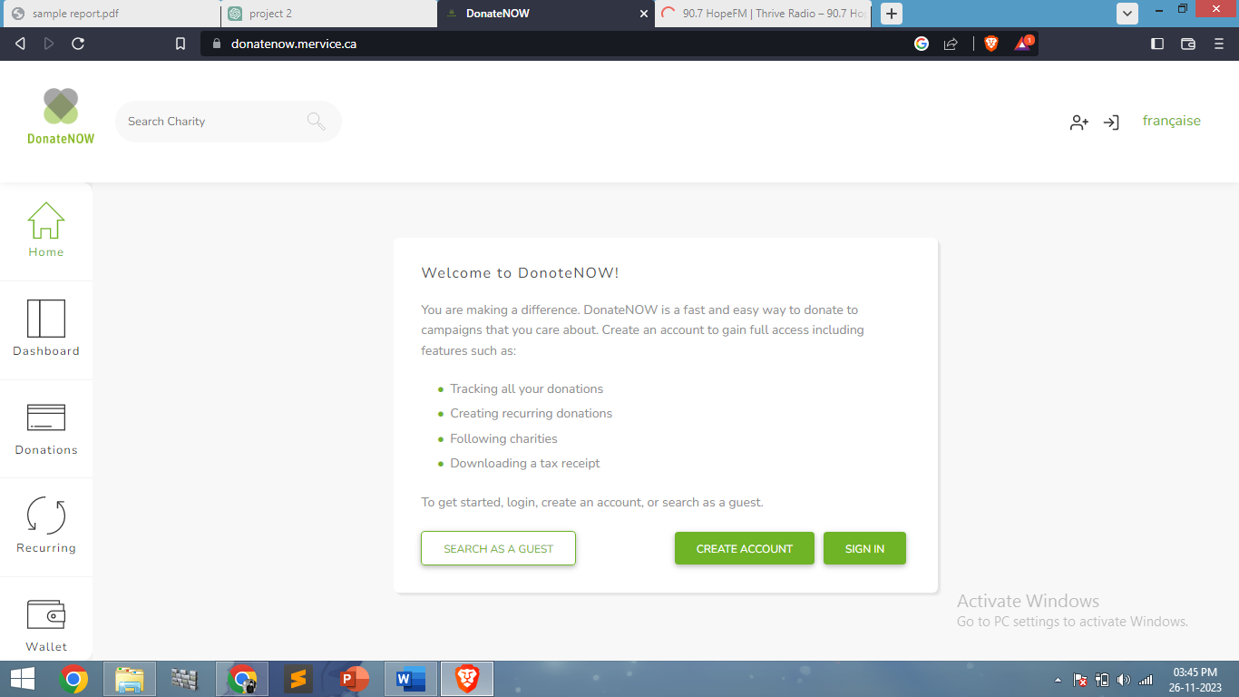

**How SupportSail Solves Them**

* User-Friendly Interface: SupportSail emphasizes a simple, intuitive interface, making navigation and engagement easier for users.
* Diverse Engagement Opportunities: SupportSail offers volunteering, collaboration, and resource-sharing options, beyond just monetary contributions, enhancing user involvement.

**2. Charity Website: "HelpingHands.org"**

**Problems Identified**

* Transparency Issues: Lack of clear reporting on how donations are utilized creates scepticism among donors, impacting trust and contributions.
* Limited Community Engagement: The platform lacks a vibrant community space for users to interact, share experiences, and collaborate.

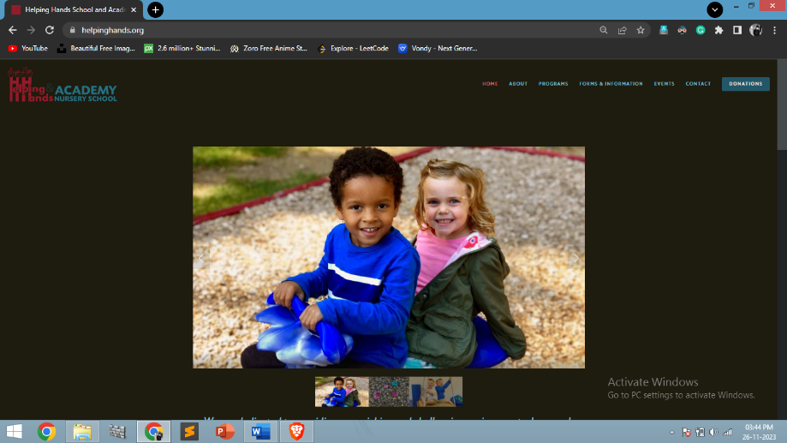

**How SupportSail Solves Them**

* Transparent Reporting: SupportSail provides detailed and transparent reporting on donation utilization, fostering trust among users and organizations.
* Vibrant Community Building: SupportSail fosters a supportive community space, encouraging interaction and collaboration among users and organizations.

1. **Donation Platform: "GiveHopeNow"**

**Problems Identified**

* Limited Organization Visibility: Smaller organizations struggle to gain visibility among potential donors due to limited platform features.
* Accessibility Challenges: The platform lacks accessibility features, limiting its reach to diverse demographics.



**How SupportSail Solves Them**

* Enhanced Organization Visibility: SupportSail provides equal visibility to

organizations of varying sizes, facilitating collaboration and visibility.

* Enhanced Accessibility: SupportSail ensures accessibility features, making it user-friendly and accessible to a broader audience.

1. **Charity Website: "CareFund"**

**Problems Identified**

* Ineffective Communication: Donors and volunteers receive limited updates or feedback regarding the impact of their contributions.
* 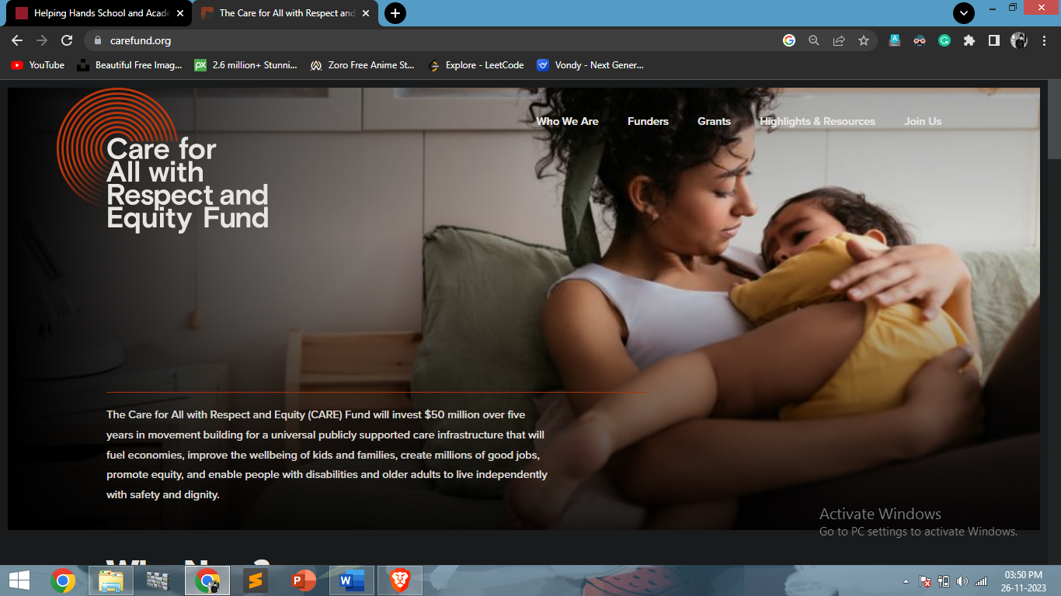Limited User Engagement: The platform struggles to engage users beyond initial donations, leading to a lack of sustained involvement.

**How SupportSail Solves Them**

* Effective Communication Channels: SupportSail maintains regular updates on contributions' impact, keeping users informed and engaged.
* Diverse Engagement Avenues: SupportSail offers diverse ways to engage, encouraging sustained involvement beyond initial donations.

1. **Donation Platform: "GivingHub"**

**Problems Identified**

* Trust and Credibility Concerns: Users question the legitimacy of listed organizations, impacting donor confidence.
* Fragmented Community: Lack of a cohesive community space limits interaction and collaboration among users.

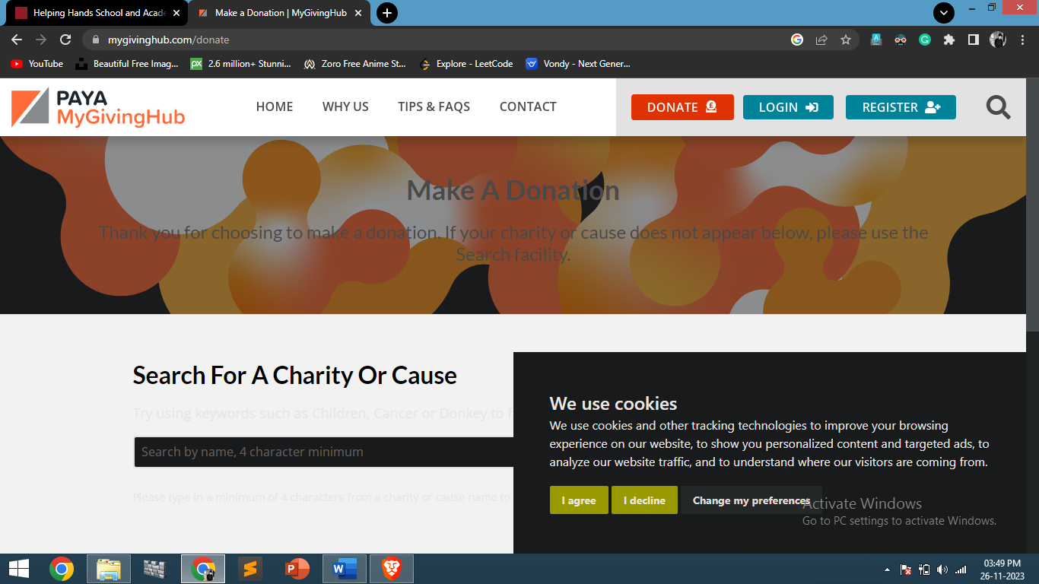

**How SupportSail Solves Them**

* Verification Processes: SupportSail implements robust verification processes, ensuring the credibility of listed organizations and fostering donor trust.
* Community-Centric Approach: SupportSail fosters a cohesive and interactive community space, encouraging collaboration and interaction among users.

SupportSail addresses these identified issues in existing donation and charity platforms by focusing on transparency, user engagement, community building, and diverse opportunities for involvement, aiming to create a robust, user-friendly, and impactful platform for donors, volunteers, and organizations.

**5. Project Planning**

Project planning involves the systematic process of outlining, organizing, and defining the tasks, resources, timelines, and objectives necessary for the successful execution of a project. Effective project planning lays the foundation for a well-structured, organized, and manageable project, enabling efficient execution and successful project completion.

**5.1 project Scope**

5.1.1. Objective

SupportSail aims to create a user-centric online platform that facilitates seamless connections between donors, volunteers, organizations, and causes. It focuses on fostering collaboration, transparency, and diverse engagement opportunities in the realm of charitable contributions.

**5.1.2. Deliverables**

* Functional Platform: A fully operational website with intuitive navigation and features for donations, volunteering, collaboration, and resource-sharing.
* User Profiles: User-friendly profiles for individuals and organizations, enabling them to engage and interact effectively.
* Transparent Reporting: Reporting mechanisms providing clear insights into donation utilization and impact achieved.
* Community Space: A vibrant community space facilitating interaction, collaboration, and knowledge sharing among users and organizations.

**5.1.3 Constraints and Limitations**

* Time: Completion within the defined timeline to ensure completion and functionality.
* Technology: Utilization of appropriate technologies and tools within specified constraints and Knowledge.
* Scalability: Considerations for future scalability without compromising current functionality.

**5.1.4 Exclusions**

* SupportSail will not engage in direct fundraising activities but will provide a platform for facilitating donations and connections between donors and organizations.
* It will not endorse or prioritize specific causes or organizations but will offer equal visibility and opportunities to all registered entities.
* SupportSail will not charge fees from the donation received but will operate on ad revenue.

**5.2 Development Plan**

**5.2.1. Project Initiation**

Goals

* Define project objectives, scope, and deliverables.
* Establish project team roles and responsibilities.

Activities

* Conduct a kick-off meeting.
* Define project charter, objectives, and scope statement.

**5.2.2. Requirement Analysis**

Goals

* Identify user requirements, features, and functionalities.
* Gather technical specifications and resource needs.

Activities

* Conduct surveys to gather user needs and browse current platforms.
* Document functional and technical requirements for the platform.

**5.2.3. Design Phase**

Goals

* Create charts, prototypes, and design layouts.
* Define user interface and user experience (UI/UX) elements.

Activities

* Develop mock-ups for the platform.
* Design user interfaces, considering usability and aesthetics.

**5.2.4. Development**

Goals

* Build the platform based on defined requirements and designs.
* Develop functionalities and integrate necessary features as much as possible.

Activities

* Code the front-end using HTML, CSS, and JavaScript.
* Implement server-side logic using JSP and backend using MY-SQL.

Test and debug functionalities iteratively.

**5.2.5. Testing**

Goals

* Ensure the platform functions as intended and meets user needs.
* Identify and resolve any bugs or issues.

Activities

* Perform unit testing, integration testing, and user acceptance testing (UAT).
* Conduct quality assurance to ensure platform reliability and usability.

**5.2.6. Documentation and Project Report**

Goals

* Document project processes, code, and procedures.
* Create a project report about the entire process.

Activities

* Create technical documentation for codebase and platform usage.
* Conduct knowledge-sharing sessions with the team.

**5.3 Team Structure**

**5.3 Project Deliverables**

**5.3.1 Project Report**

Project report serves as a comprehensive document outlining the objectives, progress, achievements, and outcomes of SupportSail, providing with a detailed overview of the project's journey and results. It consolidates key insights, analyses, and Development Process, serving as a valuable reference for future initiatives and processes.

**5.3.1 Project Documentation**

A complete documentation is given in the form of SRS-Software Requirement Specification (SRS) it provided an introduction of the current system and the system to be built. This overview includes the purpose of SRS and a brief knowledge of the current system. The overview also provided of an introduction of the proposed system.

**6. Design**

**6.1 Logical Design**

The following are the objectives of Logical design

* + Analyse all functions.
  + The ER diagram constructed by keeping in my general entries related to student and relation with other entities.
  + Transformation of conceptual Data Model into a Relational Model with data specifications.

**6.1.1 Entities Defined**

Entities are the principal data object about which information is to be collected. Entities are either concrete or abstract such as a person, places. things or events which have relevance to the database.

**6.1.2 Attributes Defined**

The attributes that are identified as part of the entities are listed along with their description:

**Organizations Table Structure volunteerdata Table Structure**

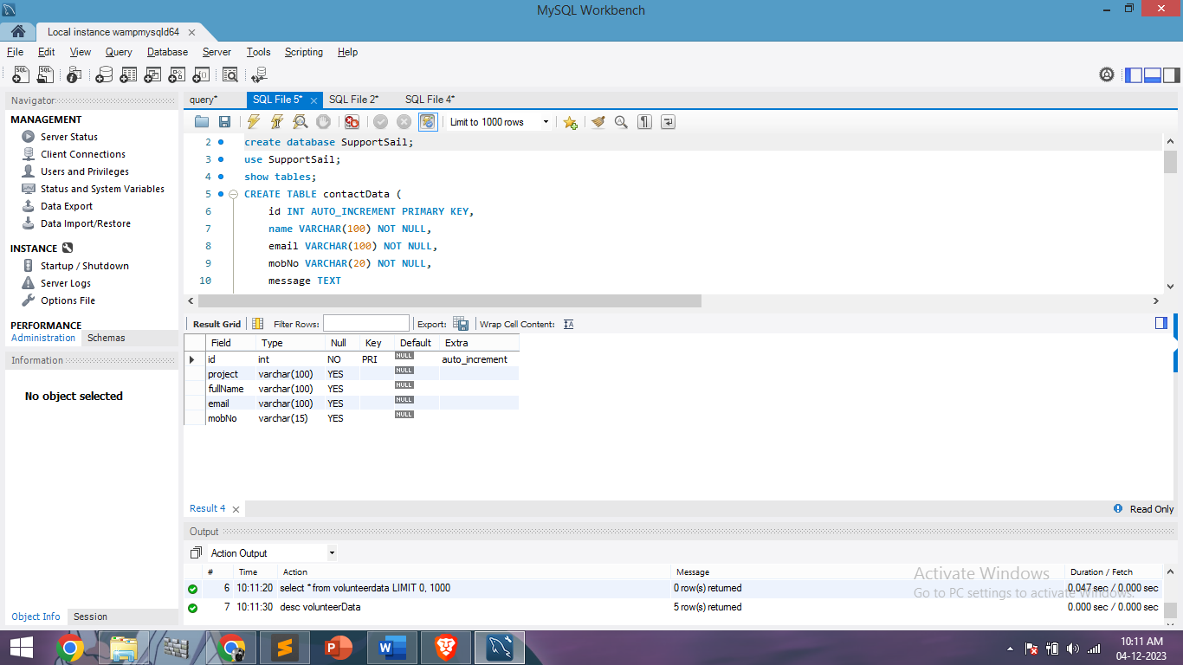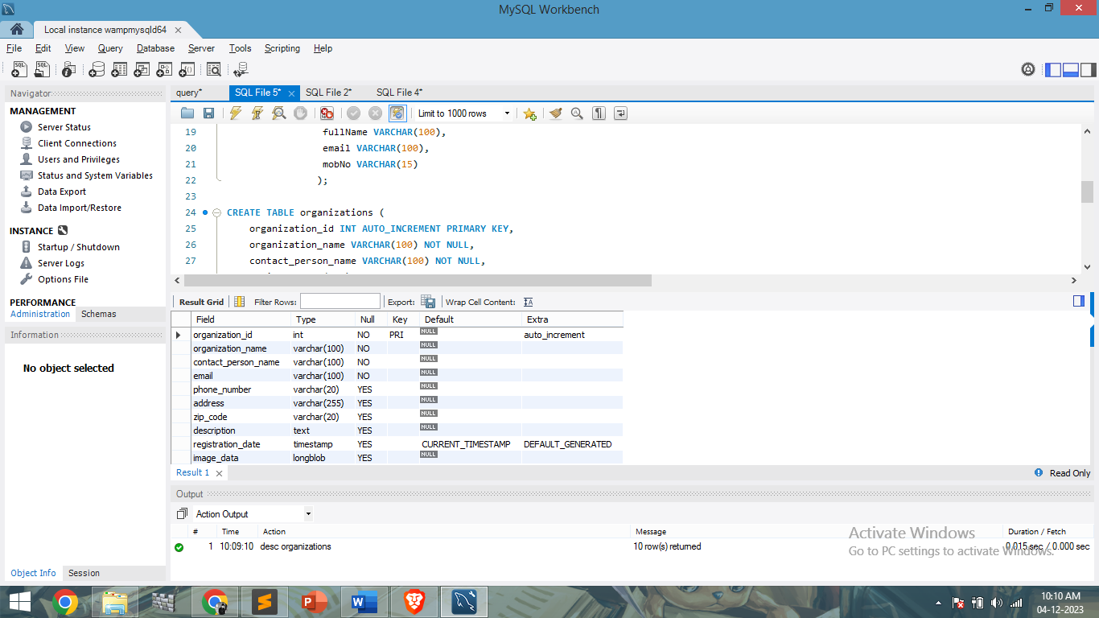

* **Donations Table Structure ConntactData Table Structure**

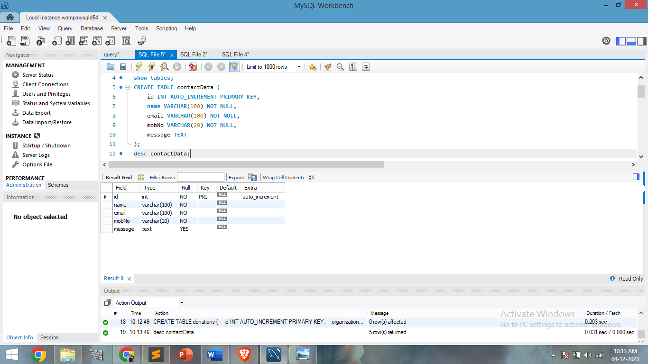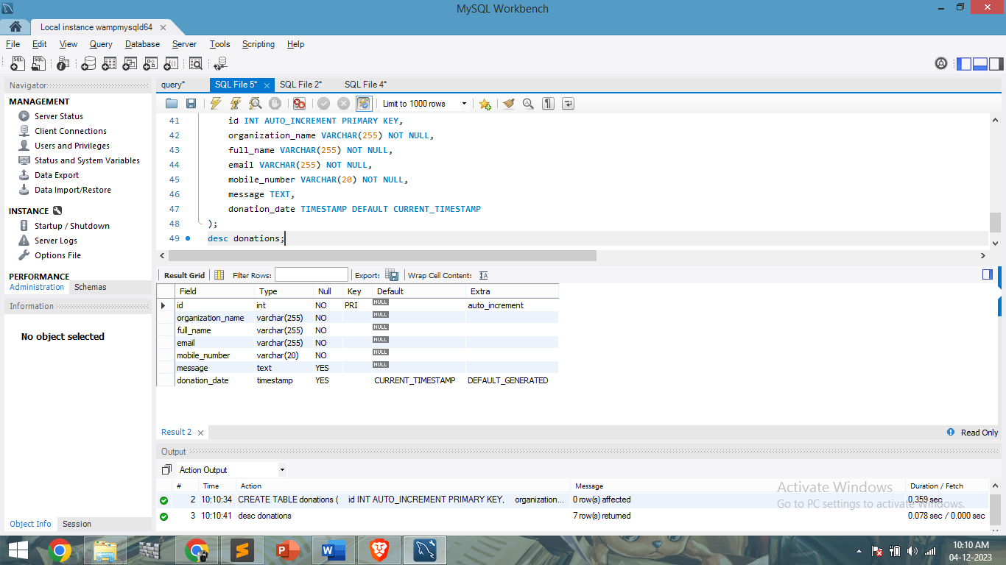

**6.2 Physical Design**

**6.2.1 user Interface**

**1: Index.htm(Landing Page)**

Landing Page: SupportSail's landing page welcomes visitors with a vibrant interface, highlighting its mission to empower charitable organizations. Through captivating visuals and concise messaging, it introduces users to the platform's key features, encouraging exploration.

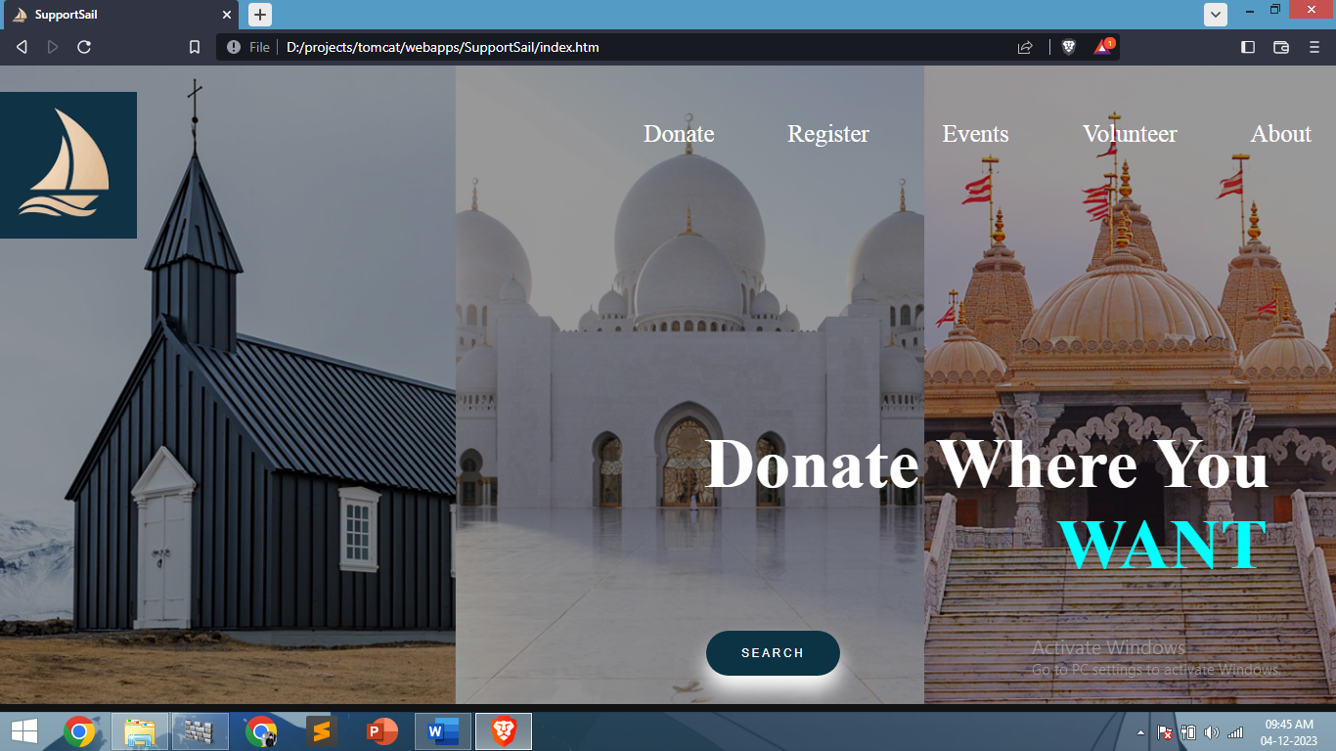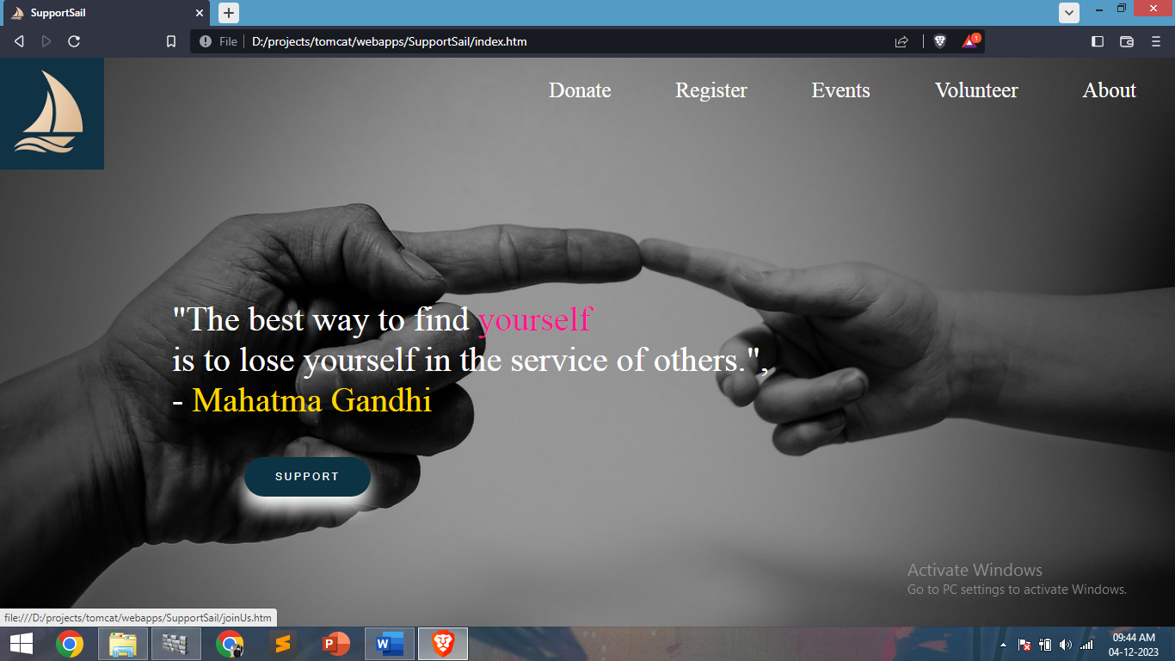

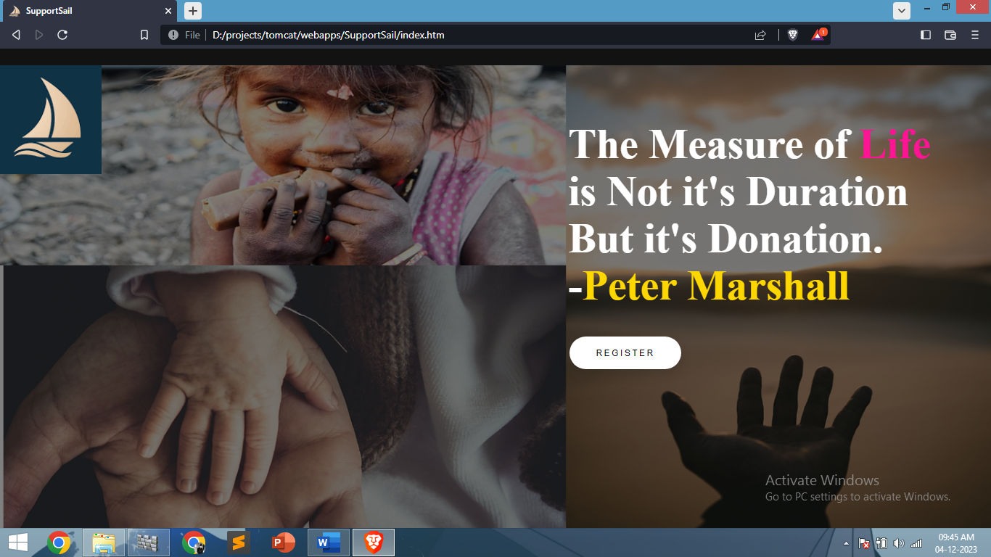

**2: About Page**

The About page on SupportSail provides an in-depth narrative, sharing the platform's origins, values, and its commitment to fostering positive change. It sheds light on the team behind the scenes, showcasing their dedication and passion for philanthropy.

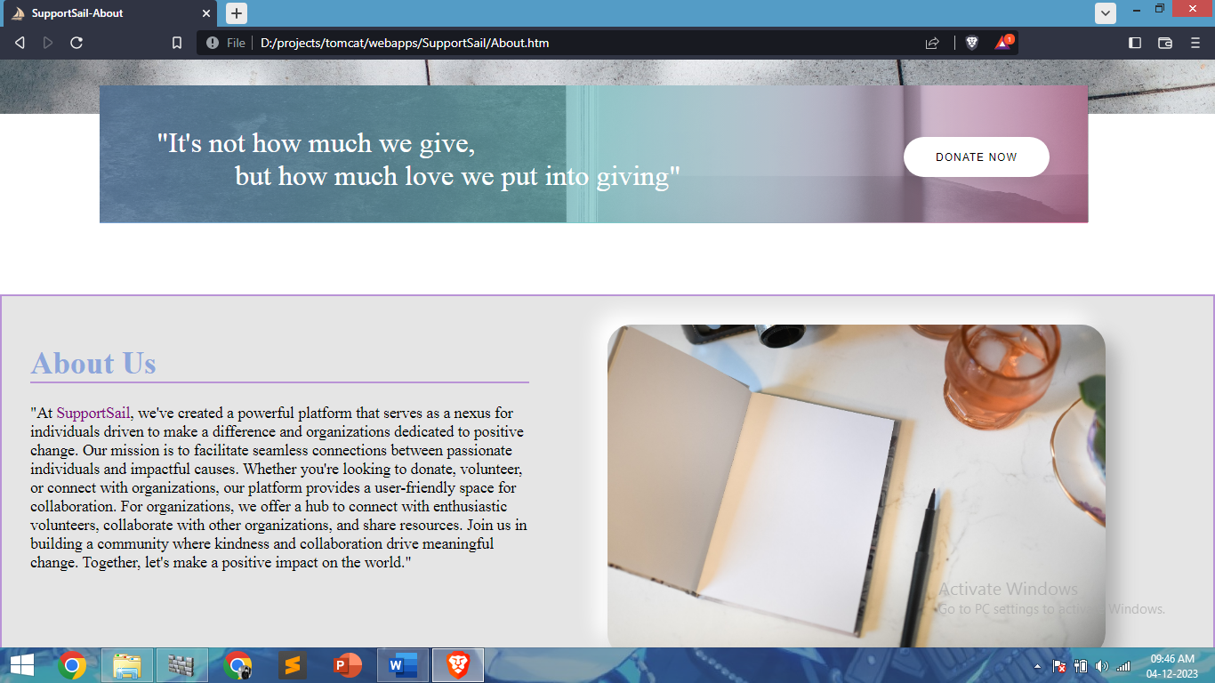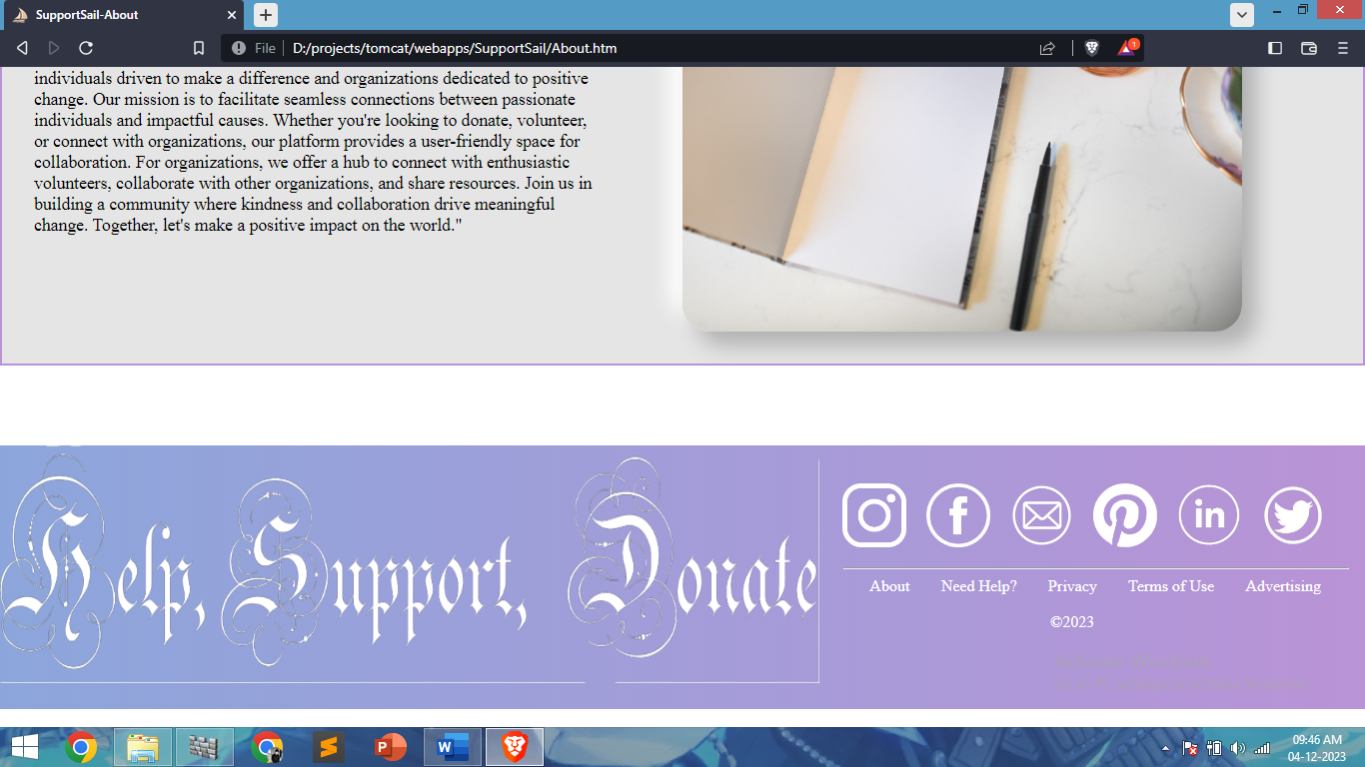

**3: Volunteer Page**

On the Volunteer page, SupportSail invites individuals to contribute their time and skills to meaningful causes. It offers details about ongoing projects, volunteer opportunities, and ways for individuals to get involved, fostering a sense of community engagement.

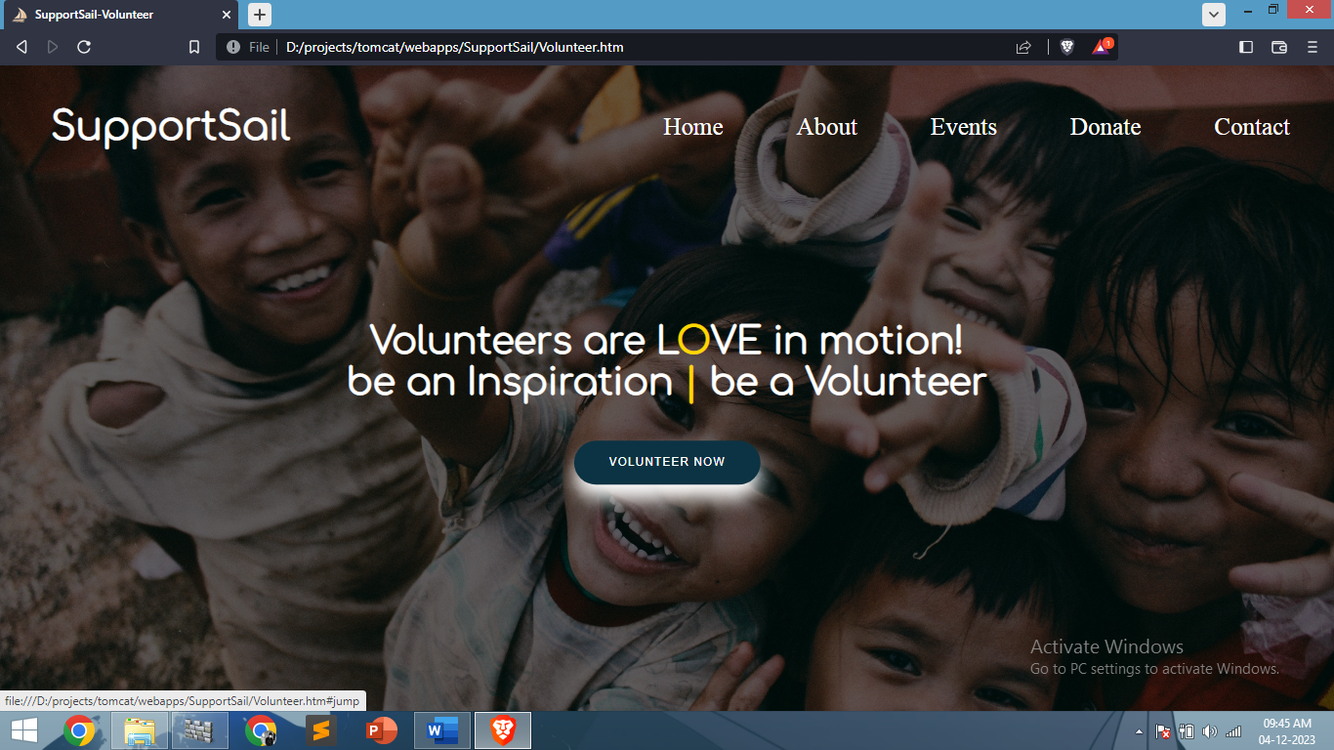

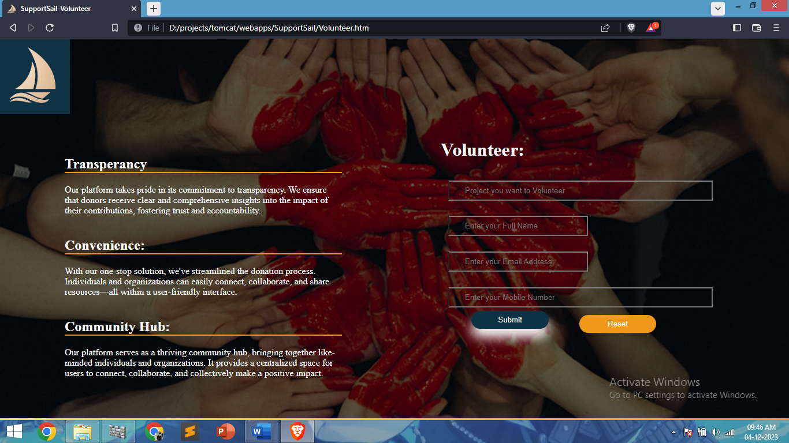

**4: Donate Page**

SupportSail's Donate page serves as a gateway for individuals and organizations eager to make a difference. It outlines various donation avenues, providing secure payment options and transparent insights into where contributions go, inspiring trust and generosity.

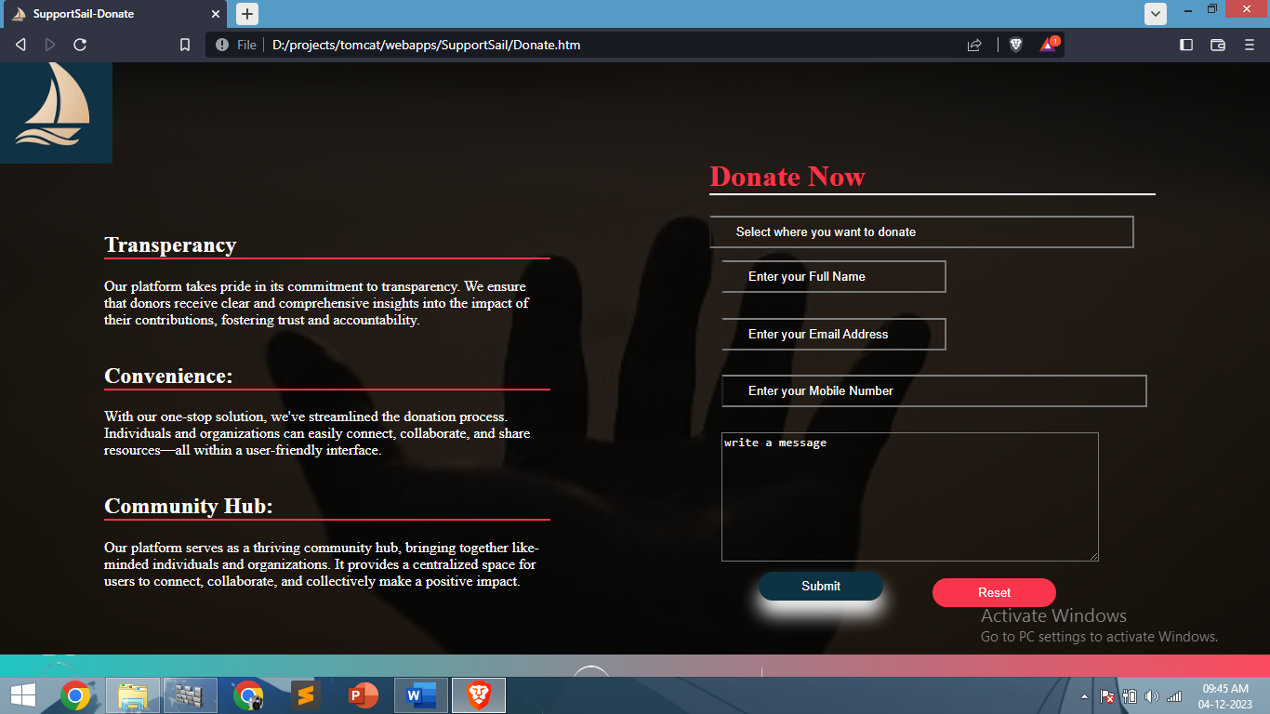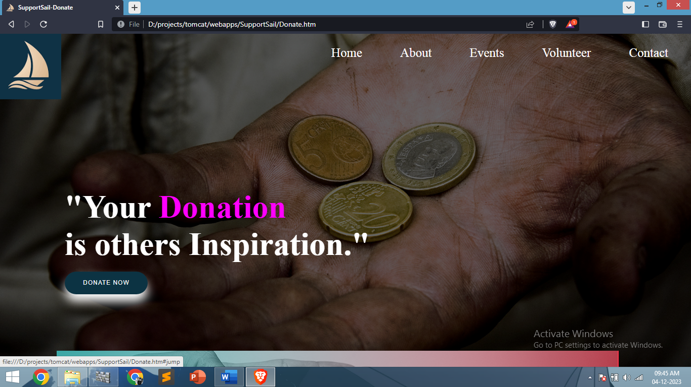

**5: Join Us Page**

The Join Us page acts as a gateway for organizations seeking to partner with SupportSail. It presents a streamlined process for registration, offering insights into the benefits of collaboration and how the platform can amplify their impact.

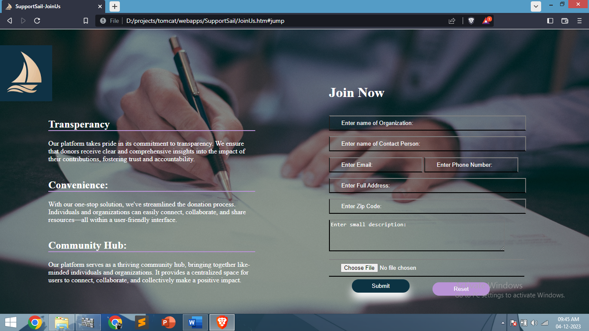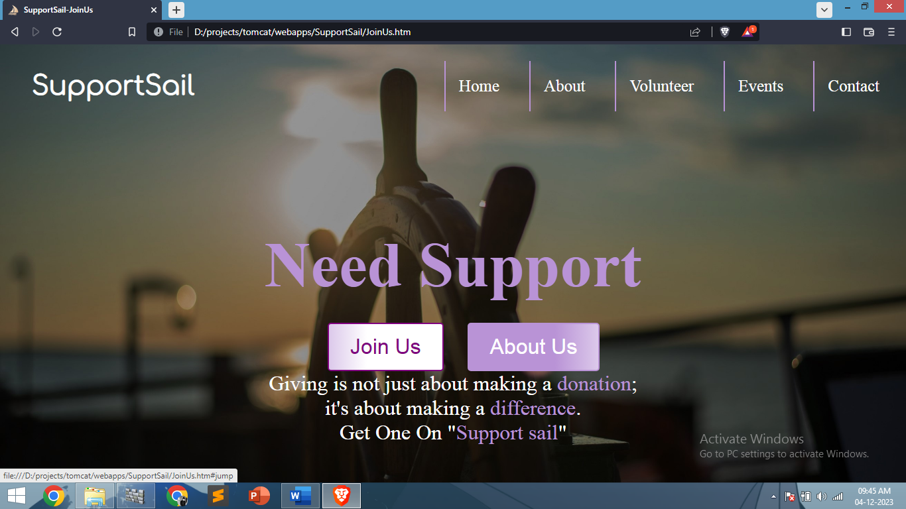

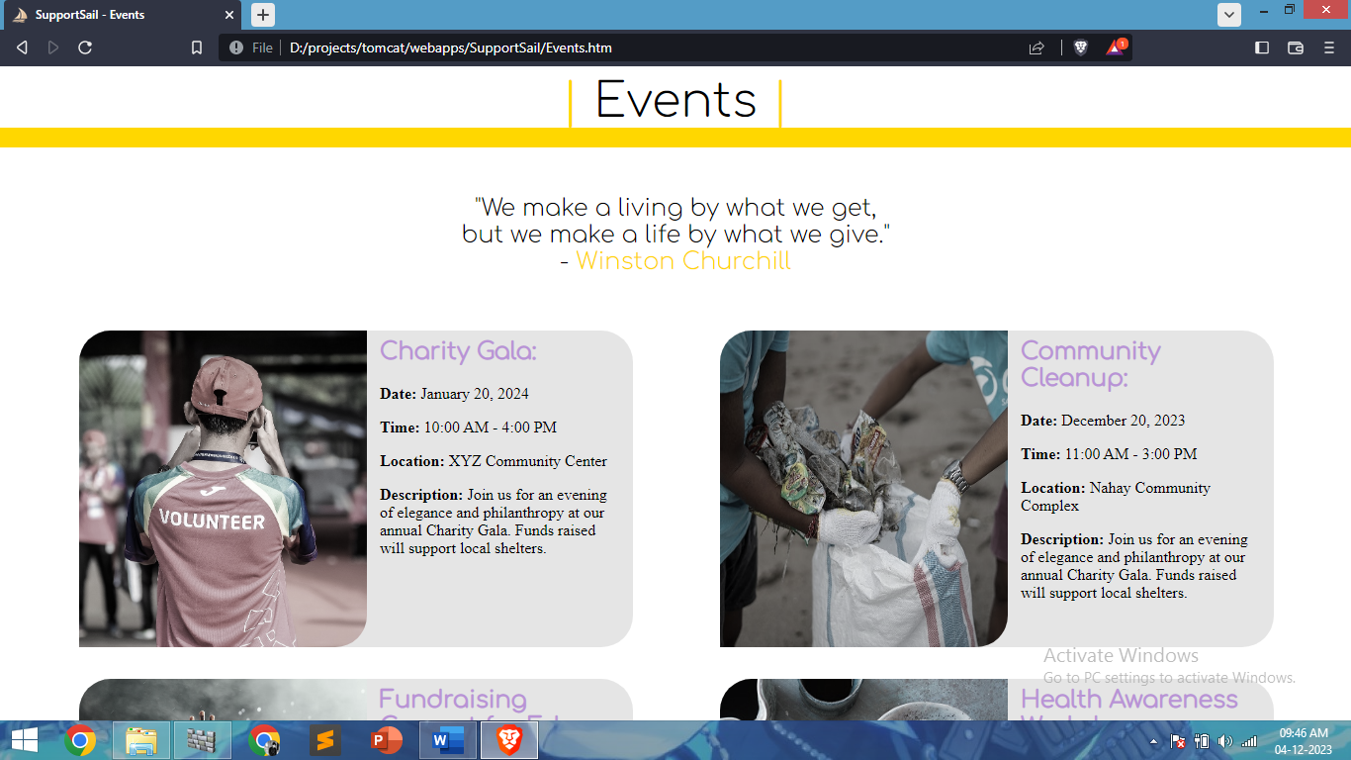**6: Events Page**

SupportSail's Events page serves as a hub for upcoming activities and initiatives. It showcases a diverse array of events, ranging from fundraisers to awareness campaigns, encouraging participation and engagement within the community.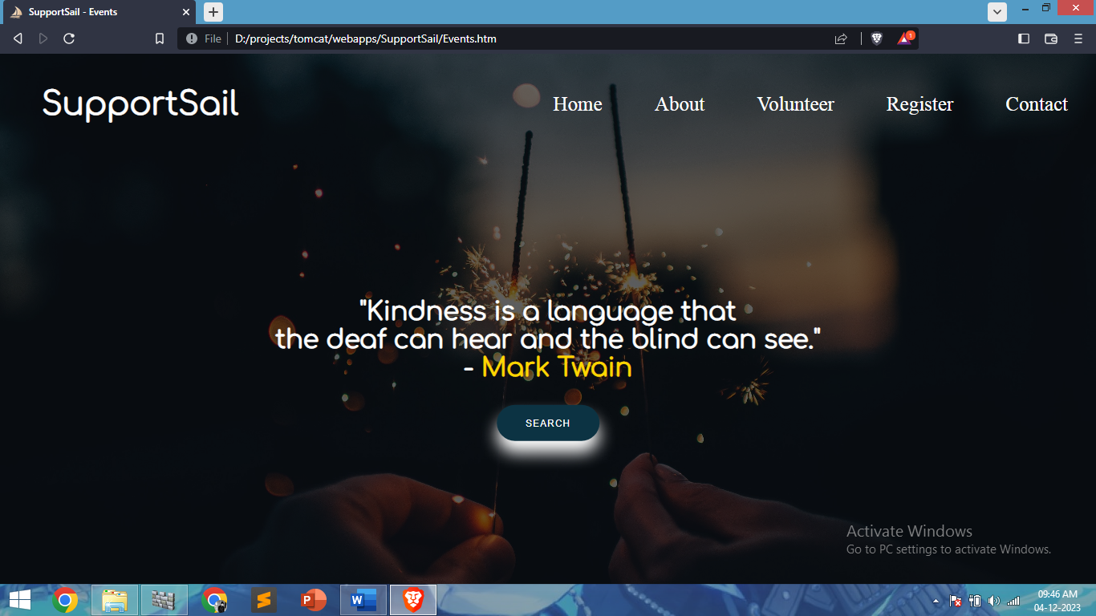

**7: Contact Us Page**

The Contact Us page offers users a direct line of communication with SupportSail. It provides contact details, a user-friendly form, and FAQs to address queries promptly, fostering open dialogue and ensuring user satisfaction.

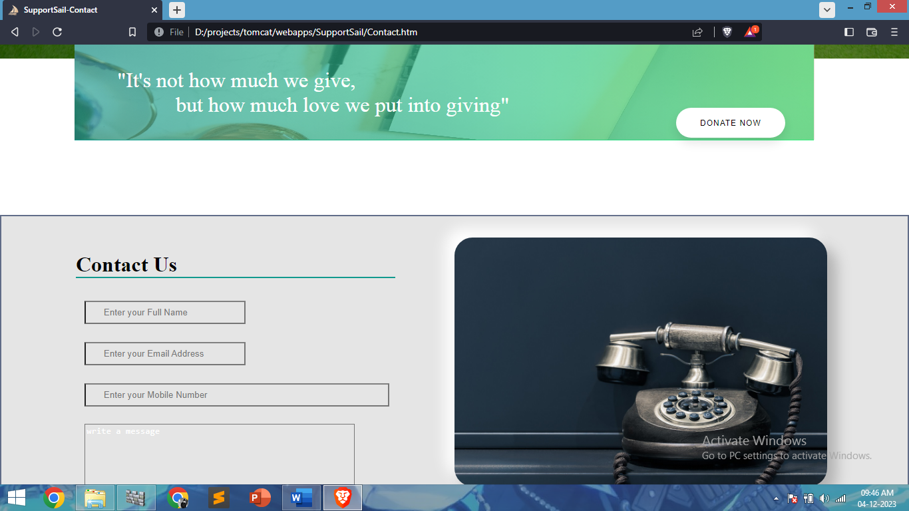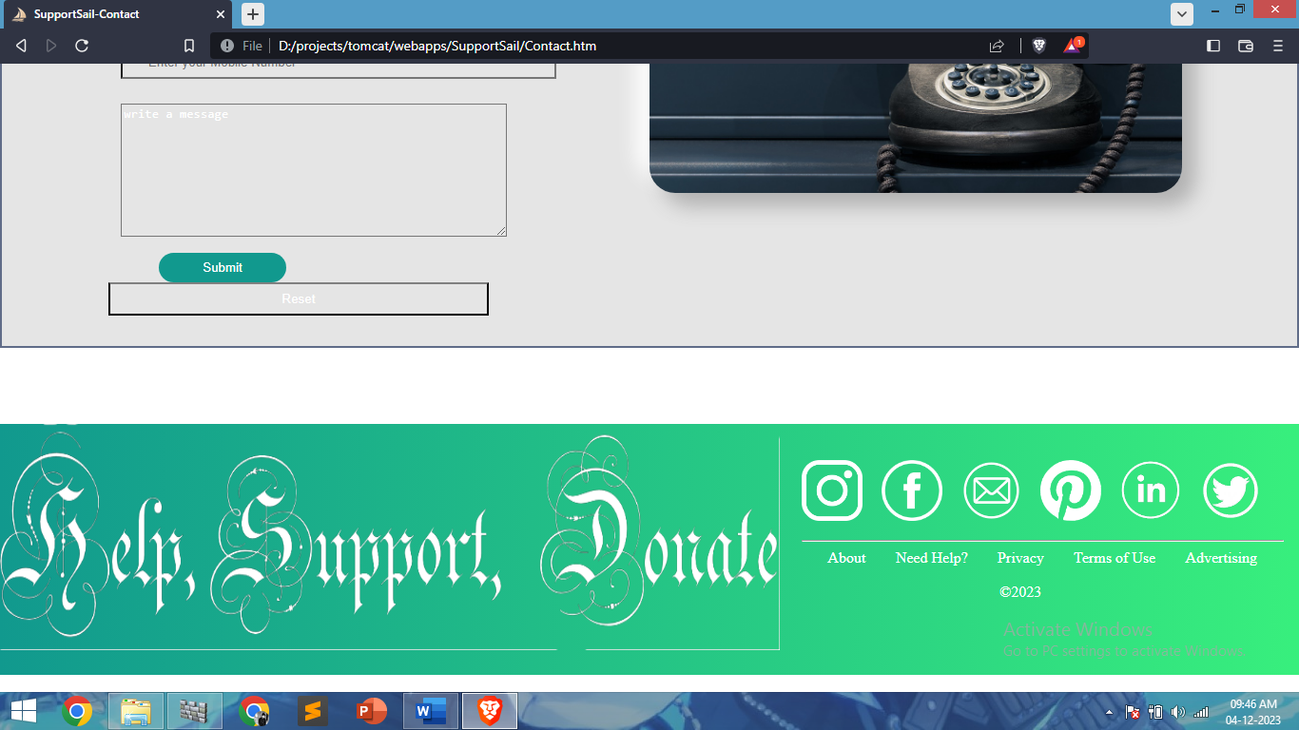

**6.2.2 Backend**

**1. Organizations table**

CREATE TABLE organizations (

organization_id INT AUTO_INCREMENT PRIMARY KEY,

organization_name VARCHAR(100) NOT NULL,

contact_person_name VARCHAR(100) NOT NULL,

email VARCHAR(100) NOT NULL,

phone_number VARCHAR(20),

address VARCHAR(255),

zip_code VARCHAR(20),

description TEXT,

registration_date TIMESTAMP DEFAULT CURRENT_TIMESTAMP,

image_data LONGBLOB

);



**2. donations table**

CREATE TABLE donations (

id INT AUTO_INCREMENT PRIMARY KEY,

organization_name VARCHAR(255) NOT NULL,

full_name VARCHAR(255) NOT NULL,

email VARCHAR(255) NOT NULL,

mobile_number VARCHAR(20) NOT NULL,

message TEXT,

donation_date TIMESTAMP DEFAULT CURRENT_TIMESTAMP

);



**3. volunteerData table**

CREATE TABLE volunteerData (id INT AUTO_INCREMENT PRIMARY KEY,

project VARCHAR(100),

fullName VARCHAR(100),

email VARCHAR(100),

mobNo VARCHAR(15)

);



**4. contactData table**

CREATE TABLE contactData (

id INT AUTO_INCREMENT PRIMARY KEY,

name VARCHAR(100) NOT NULL,

email VARCHAR(100) NOT NULL,

mobNo VARCHAR(20) NOT NULL,

message TEXT);



**7. Implementation**

The implementation phase of a project involves executing the plans and putting them into action to achieve the project's objectives. It encompasses the practical application of strategies, resources, and processes outlined in the project plan. This phase involves deploying the developed solution, monitoring progress, resolving issues, and ensuring a smooth transition to the operational stage. Successful implementation requires effective coordination among team members, adherence to timelines, resource allocation, and continuous evaluation to ensure alignment with the project's goals and objectives.

1. **Testing**

Testing should be done throughout the implementation process. Even before an application is installed, it makes sense to verify that the basic platform is capable of achieving its design capabilities. System testing is a critical process. Testing is process of executing a program with the explicit intention of finding errors that is, making the program fail. I his help in finding the bottlenecks in the system. Executing program in a simulated environment testing. The feedback from testing phase generally produces changes in the software to deal with errors and failures that are uncovered.

**8.1 Black-Box Testing**

In Black Box testing or functional testing test cases are decided. Test cases are decided on the basis of the requirements or the specifications of the program or module.

Black-box testing focuses on testing the system's functionalities without considering its internal structure or code implementation. Testers examine the system's inputs and outputs based on specifications, requirements, and user expectations.

* Incorrect or missing functions
* Interface errors
* Errors in data structure or external database access.
* Behavioural or performance error.
* Errors in initiation & termination.

**Advantages**

It ensures test scenarios are based on user perspectives, allowing testers to simulate real user interactions. It's effective for high-level testing and uncovering functional issues.

**Disadvantages**

Inability to test all code paths or potential system vulnerabilities within the codebase.

**8.2 White-Box Testing**

The White-Box testing or Structural: testing performs close operation of procedural details. They test the software logical path by having test cases exercising specific sets of conditions al loops.

White-box testing examines the internal structure, code logic, and implementation details of the system being tested. Testers have access to the system's internal architecture, source code, and design, enabling tests that validate the system's internal behaviour.

* All module path has been exercised at least once.
* Exercised on logical decisions.
* Executed all loops at their boundaries and within their operational Bounds.
* Exercised Internal data structures to ensure their validity.

**Advantages**

Allows for thorough testing of code paths, logic errors, and potential vulnerabilities within the codebase. It facilitates optimization and code quality improvements.

**Disadvantages**

It might miss out on higher-level functionalities or user-driven issues that might not be evident from the code's perspective.

**Key Differences**

* Focus: Black-box testing focuses on functionalities, while white-box testing targets code structure and internal logic.
* Knowledge: Black-box testers don't require knowledge of internal code, while white-box testers need understanding of internal workings.
* Testing Types: Black-box includes functional, acceptance, and system testing; white-box includes unit testing, code coverage, and structural testing.

**8.3 Unit Testing**

* Objective: Focuses on testing individual units or components of the software in isolation.
* Scope: Tests specific functions, methods, or modules to ensure they perform as expected.
* Methodology: Developers typically perform unit tests during the development phase.
* Tools: Test frameworks like JUnit (for Java), Mocha (for JavaScript) are used.
* Advantages: Helps in early bug detection, promotes code quality, and aids in code refactored
* Disadvantages: Might not catch integration issues or interactions between units.

**8.4 Integration Testing**

* Objective: Tests the interaction and integration between different units or modules.
* Scope: Focuses on verifying interactions between various units to ensure they work together as intended.
* Methodology: It verifies the functionality of combined units.
* Approaches: Top-down, bottom-up, or incremental integration strategies are used.
* Advantages: Validates interactions between units, detects interface issues, and ensures proper integration.
* Disadvantages: Requires comprehensive planning and may be complex to execute for large systems.

**8.5 System Testing**

* Objective: Tests the entire software system as a whole, ensuring it meets specified requirements.
* Scope: Evaluates the system's compliance with functional and non-functional requirements.
* Methodology: Performed after integration testing, checking end-to-end functionalities.
* Testing Types: Includes functional testing, performance testing, security testing, etc.
* Advantages: Validates overall system functionality, uncovers usability issues, and ensures alignment with user expectations.
* Disadvantages: Often requires more extensive resources, might not catch detailed integration issues.

**9. Future Perspectives**

At SupportSail, we envision an exciting future shaped by innovation, collaboration, and meaningful impact. As we continue our journey, our commitment to fostering positive change remains unwavering, and our aspirations for the platform are vast and transformative.

* **Embracing Technological Advancements**

We are dedicated to staying at the forefront of technological advancements. Our future involves leveraging cutting-edge tools, AI-driven solutions, and data analytics to enhance user experiences, streamline processes, and maximize the platform's efficiency.

* **Expansion of Engagement Opportunities**

Our roadmap includes diversifying engagement avenues, offering a myriad of opportunities beyond donations and volunteering. We aim to introduce mentorship programs, skill-sharing platforms, and collaborative projects, fostering a vibrant ecosystem for knowledge exchange and personal growth.

* **Global Outreach and Impact**

SupportSail is poised to transcend borders and make a global impact. Our goal is to expand our reach, partnering with diverse organizations, causes, and communities worldwide. We aim to create a truly inclusive platform that resonates with individuals and entities across the globe.

* **Advocacy for Social Causes**

Beyond just facilitating connections, SupportSail aspires to be a beacon for advocacy and awareness. We aim to use our platform to highlight social causes, drive campaigns, and influence change by mobilizing our community towards important societal issues.

* **Empowering Communities, One Step at a Time**

Our long-term vision involves empowering communities to become self-sustaining. Through education initiatives, capacity-building programs, and resource-sharing networks, we aim to equip communities with the tools and knowledge needed for long-term growth and resilience.

* **Collaborative Innovation-**

We foresee SupportSail as a hub for collaborative innovation. Our plans include fostering partnerships with research institutions, startups, and innovators to develop ground-breaking solutions that address pressing societal challenges.

**10. Limitations and Conclusions**

* **Limitations**

As we propel SupportSail towards its mission of fostering collaboration and positive change, we acknowledge certain limitations and areas where our platform may encounter challenges:

* **Technological Constraints**

While we strive to leverage the latest technology, rapid advancements may pose challenges in integrating new features seamlessly. Compatibility issues or evolving tech landscapes might affect the platform's scalability and performance.

* **Resource Limitations**

Resource constraints, both in terms of funding and infrastructure, may impact the speed and breadth of our platform's development. Limited resources might influence the pace at which new functionalities are introduced or the extent of global outreach achieved.

* **User Adoption and Engagement**

Encouraging widespread user adoption and sustained engagement remains a challenge. Convincing diverse user segments to actively participate, contribute, and embrace the platform's offerings requires continuous effort and persuasive strategies.

* **Regulatory and Compliance Challenges**

Adhering to diverse regulatory frameworks, especially in a global context, poses challenges. Ensuring compliance with data privacy laws, donation regulations, and international standards demands ongoing vigilance and adaptation.

**Conclusions**

In conclusion, while acknowledging these limitations, the journey of SupportSail has been one of immense growth, learning, and positive strides toward its envisioned impact. Despite these constraints, several key conclusions can be drawn:

* **Continuous Improvement**

Recognizing the limitations serves as a catalyst for continuous improvement. We are committed to addressing these challenges head-on, learning from them, and evolving our strategies and functionalities to overcome barriers.

* **User-Centric Approach**

The user remains at the heart of our endeavours. Our commitment to understanding and meeting user needs drives our efforts to enhance the platform's usability, engagement, and overall experience.

* **Collaborative Resilience**

The challenges encountered have reinforced the importance of collaboration and resilience. We recognize that collective efforts, partnerships, and a supportive community are crucial in navigating limitations and fostering impactful change.

* **Optimistic Future Outlook**

While acknowledging limitations, we remain optimistic about SupportSail's future. Our resolve to make a meaningful difference and create a vibrant platform for positive change remains unwavering.

**11. Bibliography and References**

1. W3Schools. (n.d.). HTML Tutorial. Retrieved from https://www.w3schools.com/html/
2. MDN Web Docs. (n.d.). CSS: Cascading Style Sheets. Retrieved from https://developer.mozilla.org/en-US/docs/Web/CSS
3. JavaServer Pages (JSP) - Oracle Help Center. (n.d.). Retrieved from https://docs.oracle.com/javaee/7/tutorial/jsf-facelets001.htm
4. MySQL Documentation. (n.d.). Retrieved from https://dev.mysql.com/doc/
5. Stack Overflow. (n.d.). Programming Q&A. Retrieved from https://stackoverflow.com/
6. Apache Tomcat. (n.d.). The Apache Tomcat® Project. Retrieved from <http://tomcat.apache.org/>